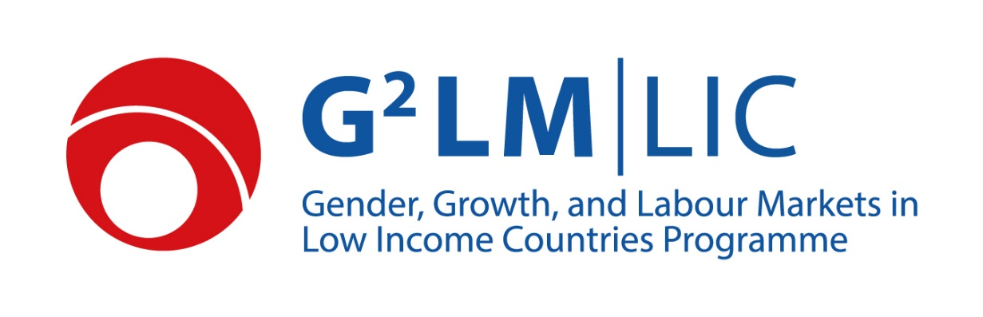

Phase V Project Proposal
A.1 Project Title (max. 150 characters):
[Title]

A.2 Abstract (Fill the sections below, max 300 words for all the three sections together):
- Research question:

- Design/methodology/approach:

- Impact for policy makers and other stakeholders:

A.3 Presenting Institution (lead partner):
[Institution]

A.4 Application Number:
[X-XXXX]

A.5 Country/Countries of Research
[Country/countries where the research activities/analyses take place]

B.1 Researchers:
[Names and short bios of researchers, Principle Investigator first]

B.2 Resubmission:
[In case of a resubmission, summarize here how your revised proposal differs from the original submission] (Note: resubmissions will not be considered unless you have received a message from us stating otherwise.)

C.1 Other Support:
[Describe in detail other sources of funding sought or received for this project and related research]

C.2 Staff:
[Other than the team of researchers]

C.3 Timetable:

D. Research Proposal: Please fill in all the sections (in Arial pt 12, Calibri pt 11 or similar font), 1.5 line spacing
Research question, motivation (max 1 page)
Fit with the aim of the program (max 1 page)
Contribution to the literature (max 1 page)
Methodology/research design (max 5 pages)

E.1 Impact Plan:
[Please state who will benefit from your research and which actions you plan to undertake to ensure that such benefits are realized. For proposals that entail field research in collaboration with policy makers or organizations please include an engagement plan to describe how you plan to communicate the results of your research and which systems you will put in place to ensure that your policy partner has reasonable access to the research. For proposals that entail the collection of new data please include a dissemination plan to describe how others will be able to access the data and the support you will provide. E.1: max 2 pages A4]

E.2 Capacity Building:
[Discuss the involvement of researchers and institutions based in low-income countries, and ways in which the project will increase research capacity in low-income countries. max 1 page A4]

F. Ethics
Please think carefully about the following questions and comment as necessary: Are you providing information that can hurt psychologically, financially or physically any person whether they are part of the research or not? If your research contains an experiment, are any of the treatments capable of generating harm, direct or indirect, to the participants or anyone else? Can the results of your research be used to discriminate or otherwise hurt someone?

G. Data Management and Sharing:
[Please provide a short overview of methods employed to ensure that sensitive data is sufficiently protected and how any applicable data protection regulation is addressed. Also include a data sharing plan with timetable for open access release.]

H. Curricula Vitae:
[Include CVs of all researchers; max 4 pages each, including relevant publications]

